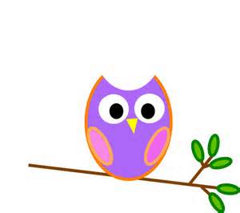s

**Mrs. Stewart’s Class News**

School Phone: (336) 871-2400

Email: [amber.stewart@stokes.k12.nc.us](mailto:amber.stewart@stokes.k12.nc.us)

Class Website: [www.amberstewartsclass.weebly.com](http://www.amberstewartsclass.weebly.com)

**Upcoming Events**

*April 10: Report Cards

*April 20: PTA Meeting/ Science Night @6:15

*April 22: Earth Day

*May 15: Dan Nicholas Park Field Trip (See attached)

*May 25: Memorial Day Holiday/NO SCHOOL

**Homework**

*Please have your child read their Take-Home books to you every night. When your child is reading please avoid eye contact with them. *Eye contact when reading with them is making students not “think” about their reading strategies.*

**Birthdays**

Maria 4/22



**What are we learning?**

During the month of April we will be learning about the following themes: Spring, birds, Earth Day/Plants and Frogs. During the last quarter of school we will review everything we have learned all year. For science and social studies we will focus on “changes” that occur in several different areas.

**Practice at Home**

*Please work with your child on the following things at home:

Everyday things

-tying shoes

-zipping jacket

School things

-Say a random number; have your child start counting at that number up to 100.

-Count by 5’s & 10’s

Items Needed

We are running low on the following items and would appreciate any donations to the classroom.

* Kleenex
* Kleenex
* Kleenex
* Kleenex
* We go through these FAST!