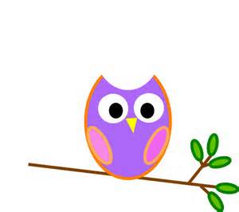

**Mrs. Stewart’s Class News**

School Phone: (336) 871-2400

Email: [amber.stewart@stokes.k12.nc.us](mailto:amber.stewart@stokes.k12.nc.us)

Class Website: [www.amberstewartsclass.weebly.com](http://www.amberstewartsclass.weebly.com)

**Upcoming Events**

*February 3: 100th Day of School *February 14: Valentine’s Day

*February 16: President’s Day/No School

**Homework**

*Please make sure that your child is completing their homework during the week. If they come to school with incomplete homework they will complete the assignments during free centers.

**Birthdays**

Calan 2/2

Shiann 2/2

Joshua 2/17



**What are we learning?**

During the month of February we will be learning about the following themes: Community Helpers, Valentine’s Day, Presidents, and Dinosaurs. For reading we will be focusing on retelling thekey points from stories. Key points include, characters, setting and main idea. We will also learn about the beginning, middle and end of a story. We will learn how to write opinion stories. Opinion stories are focused on what students like themselves. These things include their favorite book, favorite food, favorite sport, etc. For social studies we will learn about how jobs help people meet their needs and wants. In math we are going to focus on “teen numbers”. Describing objects according to their length and weight, as well as making shapes. In science we will continue to learn about the weather as well as learn about how animals are alike and different.

**Practice at Home**

*Please work with your child on the following things at home:

Everyday things

-tying shoes

-zipping jacket

School things

-reading strategies (in reading bag)

**Please DO NOT tell your child words when they are reading. MAKE them use their strategies to figure out a word they do not know.

-WISE WORDS!!!

Valentine’s Day

We will be celebrating Valentine’s Day on Friday, February 13. We will be making a Valentine’s bag to put all of our goodies in here at school next week. If students wish to send in valentines for their classmates they may do so. On Valentine’s Day we will *not* have a “party”. Mrs. Ferguson and I will provide a special snack for the class that afternoon. Below is a list of student names for Valentine’s.

Aidan Alexis Avery Calan Cayden Cloie Cole Emma

Evan Joshua Kendra Lamar Lillie Maria Noah Owen

Samantha Shiann Yocelin

**Reminders**

*If you have not sent in a change of “winter” clothes to keep here at school, please do so ASAP.

*Please make sure your children are dressed warm when they come to school.

Needed Items

*Kleenex tissues

*Computer Paper

*Snacks-cookies, gummies, chips, Teddy Grahams, etc. (We have goldfish, please do not send goldfish.)

