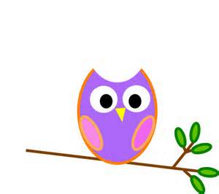

**Mrs. Stewart’s Class News**

School Phone: (336) 871-2400

Email: [amber.stewart@stokes.k12.nc.us](mailto:amber.stewart@stokes.k12.nc.us)

Class Website: [www.amberstewartsclass.weebly.com](http://www.amberstewartsclass.weebly.com)

**Homework**

*Please make sure that your child is completing their homework during the week. If they come to school with incomplete homework they will complete the assignments during centers. Homework helps me to see that they are grasping what they are learning at school when they get home.

**Birthdays**

November 2: Lillie



**Upcoming Events**

*November 4: Early Dismissal @ 11

*November 11: Veterans Day/ No School

*November 26: Early Dismissal @ 11

*November 27-28: Thanksgiving Holiday

**What are we learning?**

During the month of November our themes that we will learn about are Native Americans, Pilgrims and Thanksgiving. In social studies we will continue to learn about different types of maps. In science we will continue to learn about the weather.

We will continue to learn different letters of the alphabet and their sounds. The letters we will learn in November are: “h”, “p”, “j”, “v”, “w”, “z”, and “qu”.

**Practice at Home**

*Please continue to work on the following things at home with your child:

-Tying shoes

-Writing and spelling their name with only capitalizing their first letter.

-Reviewing “wise words” we have thus far

-LETTERS and SOUNDS

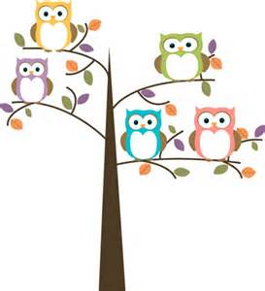

Volunteer Letter

I sent home a volunteer letter with a calendar. If you would like to volunteer please sign up for a day and return it to school. If you did not send in a Background Check sheet by October 1 you may not volunteer. You also must pass the Background Check to volunteer.

Reading Bags

Today students are going to start reading books to parents. Please read the long “Helping Your Child to Read” letter that is located inside your child’s reading bag. This will explain how we read with the kids at school.

**Reminders**

*Homework Folders are sent home on Mondays and should be returned to school on Friday’s. Homework will be listed for the week in the homework folder.

*Reading Bags are sent home each night with a new book. Parents are sign the log inside the bag and return to school the next day.