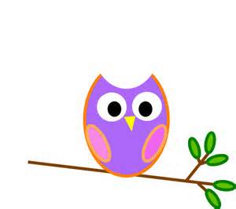

**Mrs. Stewart’s Class News**

School Phone: (336) 871-2400

Email: [amber.stewart@stokes.k12.nc.us](mailto:amber.stewart@stokes.k12.nc.us)

Class Website: [www.amberstewartsclass.weebly.com](http://www.amberstewartsclass.weebly.com)

**Homework**

*Please make sure that your child is completing their homework during the week. If they come to school with incomplete homework they will complete the assignments during centers. Homework helps me to see that they are grasping what they are learning at school when they get home.

**Birthdays**

October 24: Kendra



**Upcoming Events**

*October 7: Early Dismissal

*October 23: Early Dismissal/End of 1st Qtr

*October 24: No School/Parent-Teacher Conferences

*October 29: Report Cards

*October 31: Halloween/Halloween Parade

**What are we learning?**

During the month of October our themes that we will learn about are harvest, bats and owls, spiders, pumpkins and Halloween. In social studies we will be learning about different types of maps. In science we will continue to learn about the weather.

We will continue to learn different letters of the alphabet and their sounds. The letters we will learn in October are “Cc”, Aa”, “Ii”, Rr”, “Oo”, Gg”, “Dd”, “Ss”, “Ee” and “Uu”.

**Practice at Home**

*Please continue to work on the following things at home with your child:

-Learning lunch number.

-Tying shoes.

-Writing and spelling their name.

-Reviewing “wise words” from previous weeks: the, this, not, me, and, can, is

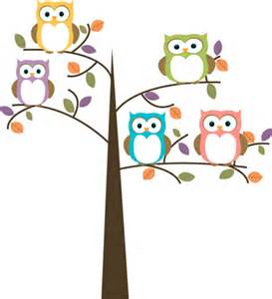

**Reading Bags**

At the beginning of school we sent home books that parents had to read to their child because kindergarten students could not read at that point. During the month of October you will see a shift in reading bags. We will start sending home books that students can read. When students are reading, they are to point to every single word as they read. This helps them keep track of what they have read and where they are going. Students have learned the reading strategy called “*Eagle Eye*”. This means that students are to use their “Eagle Eyes” to look at the pictures to help them read the words. **Please do not tell them what a word is** when they are reading. Have them use their strategies that we learn and send home for you to review.

**Reminders**

*Homework Folders are sent home on Mondays and should be returned to school on Friday’s. Homework will be listed for the week in the homework folder.

*Reading Bags are sent home each night with a new book. Parents are sign the log inside the bag and return to school the next day.