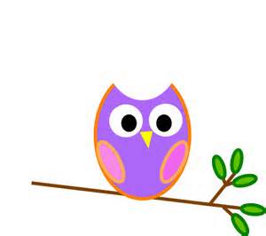

**Mrs. Stewart’s Class News**

School Phone: (336) 871-2400

Email: [amber.stewart@stokes.k12.nc.us](mailto:amber.stewart@stokes.k12.nc.us)

Class Website: [www.amberstewartsclass.weebly.com](http://www.amberstewartsclass.weebly.com)

**Upcoming Events**

*December 18: Christmas Party @ 1pm

*December 18: K-2 Christmas Program @ 6:30 (More info. to come)

*December 19: Early Dismissal @ 11am

*December 22-January 1: Christmas Break

**Homework**

*Please make sure that your child is completing their homework during the week. If they come to school with incomplete homework they will complete the assignments during free centers.

**Birthdays**

Mrs. Ferguson- 12/19

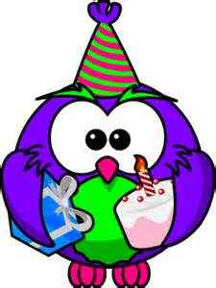

**What are we learning?**

During the month of December we will be learning about the celebration of Christmas from 13 different countries/places from around the world. We will learn about what the people eat, how they dress, etc. We will make a craft each day to represent the country we will learn about that day.

We will continue to learn different letters of the alphabet and their sounds. The letters we will learn in December are

“x” and “y”

**Practice at Home**

*Over holiday breaks, students tend to lose some of the things they have learned in class. Below are some things that you can work with your child on during Christmas break.

-Capital and lowercase letters; call out a random letter and have your child write the letter as they tell you the sound

- Writing and recognizing numbers 1-20; call out a random letter and have your child write the number

- Wise words; call out a wise word and have your child write the word down

*I will be sending home a couple sheets of paper we use here at school for when your child is practicing these things listed.

**Reminders**

*Santa’s Workshop information will be coming up soon. If you wish to help work the workshop, please send in your *red Santa’s Workshop* paper from the PTA.

**Christmas Party**

We will have our Christmas around the World Party on Thursday, December 18 at 1:00pm. I have attached a list of things we will need for the party. If you would like to sign up for something to send in for the party please detach the bottom of the Christmas Party letter and send back to me in your child’s planner. Please do not buy that item until I have confirmed in your child’s planner.



Polar Express Day

On Friday, December 19, we will have Polar Express Day. We will watch the Polar Express and have hot chocolate. The students can wear their pajamas and bed room shoes to school. No gowns for girls, pillows, blankets, stuffed animals, etc. please. In order for your child to have hot chocolate, please send in a coffee mug or small coffee thermos with a lid. Either one is fine. Coffee mugs can be sent in a bag with your child’s name anytime the week of 12/15 – 12/19. Students will need to bring their book bags on this day as well. If you have any questions please feel free to contact me here at school.

**Christmas Presents**

Students are able to send in Christmas presents to one another for the Christmas party. **Please do not feel obligated to get myself or Mrs. Ferguson something for Christmas. All of the things you have sent in for Christmas around the World crafts, as well as your time volunteering are a HUGE gift for both of us.