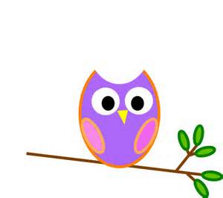

**Mrs. Stewart’s Class News**

School Phone: (336) 871-2400

Email: [amber.stewart@stokes.k12.nc.us](mailto:amber.stewart@stokes.k12.nc.us)

Class Website: [www.amberstewartsclass.weebly.com](http://www.amberstewartsclass.weebly.com)

**Homework**

*Homework Folders are sent home on Mondays and should be returned to school on Friday’s. Homework will be listed for the week in the homework folder.

*Reading Bags are sent home each night with a new book. ***Parents are to read the book to their child*** (until students start reading), sign the log inside the bag and return to school the next day.

**Birthdays**

September 8: Alexis

September 24: Cole



**Upcoming Events**

September 22: First day of Fall

**What are we learning?**

During the month of September our themes that we will learn about are ourselves as individuals and who we are as a class. We will also learn about Chicka Chicka Boom Boom, apples, farms and harvest.

*Wise Words

Wise words are our “spelling/sight” words. Students will learn a “wise word” each week. I will post these on my website as they are introduced. If you do not have internet students will have their “wise word(s)” in their Homework Folder for that week.

**Practice at Home**

Over the past week, I have noticed a couple things that my little “wise owls” need to practice at home. When your child is not at school, have ***them*** do whatever task they need to do instead of the parent/guardian…without giving in and doing it for them. I know it is hard to step back and watch them do it on their own because they are young, but they *have* to learn how to do simple tasks, like listed below, in order to function daily at school. This will help your child succeed very quickly and become much more independent.

Examples:

*Zipping and unzipping book bags.

-Give your child their planner and their reading bag to put in their book bag correctly. Show them how to do it ***one time*** and then have them to practice two or three times each night. (Unzip book bag, put planner and reading bag in book bag, zip book bag up.)

*Pushing under their chair when they stand up from a table.

-Have your child purposefully go get something when they are sitting at a table and remind them to “push” in their chair after they stand up.

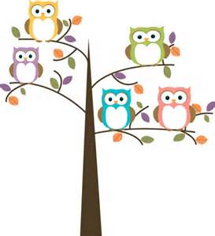

**Reminders**

*If your child is going to eat breakfast in the morning they should be dropped off at the cafeteria. If they *are not* going to eat breakfast they should be dropped off at the gym.

*Send all papers, student information sheets, etc. back to school ASAP.

*If your child does not have all shots and a school physical completed, they will receive some letters on 9/4/13 letting you know what they needed and how many days to get it taken care of.

**Stop Light Behavior**

In my classroom I use a “stop light” behavior system. Every day all students will begin with their name on *green*. If I have to call them down two times they will move their name to the *yellow/warning* on the stop light. If I have to call them down a third time students will move their name to the *red/time out* on the stop light. Each day students will receive a sticker in their planner indicating what color of the stoplight their name was on at the end of the day. If they were on *yellow* or *red* I will indicate why they were on that color and what their consequence was (walking at PE, moving to another table, etc). If for some reason their behavior does not improve after moving to *red*, they will be sent to Mr. Rose and you will receive a phone call and/or note that day from him.